**Sri Lanka Institute of Information Technology  
Kandy Uni**

**Probability and Statistics - IT2120**

Lab Submission

Lab sheet No 06

IT24103106

Ranathunga V.V.S.B.U.

**Exercise**

**(1)**

1. What is the distribution of X?

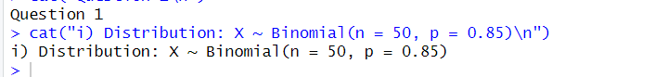

1. What is the probability that at least 47 students passed the test?

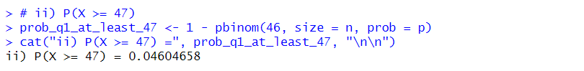

**(2)**

i. What is the random variable (X) for the problem?

ii. What is the distribution of X?

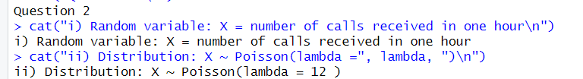

iii. What is the probability that exactly 15 calls are received in an hour?

